%% Linear Algebra: G.Strang, ” Differential Equations and Linear Algebra”, Wellesley- Cambridge Press,2014.

Chapter 4 to Chapter 8

1. Linear Equations and Inverse matrices
2. Vector Spaces and Sub Spaces
3. Eigenvalues and Eigenvectors
   1. Introduction to Eigenvalues
   2. Diagonalizing a matrix
   3. Linear System
   4. The Exponential of a Matrix 🡪 skip
   5. Second order system 🡪 skip
4. Applied mathematics and ATA
5. Fourier and Laplace Transforms
6. Applies mathematics and $A^{T}A$
   1. Least Squares and Projection

* 1) Solvable:

2) unsolvable : 🡪 How can you handle it?

We want an estimator $\hat{v}$ for v

Introduction: Given $Av=b,$ define error $e=b-A\hat{v}$. Find $\hat{v}$ such that

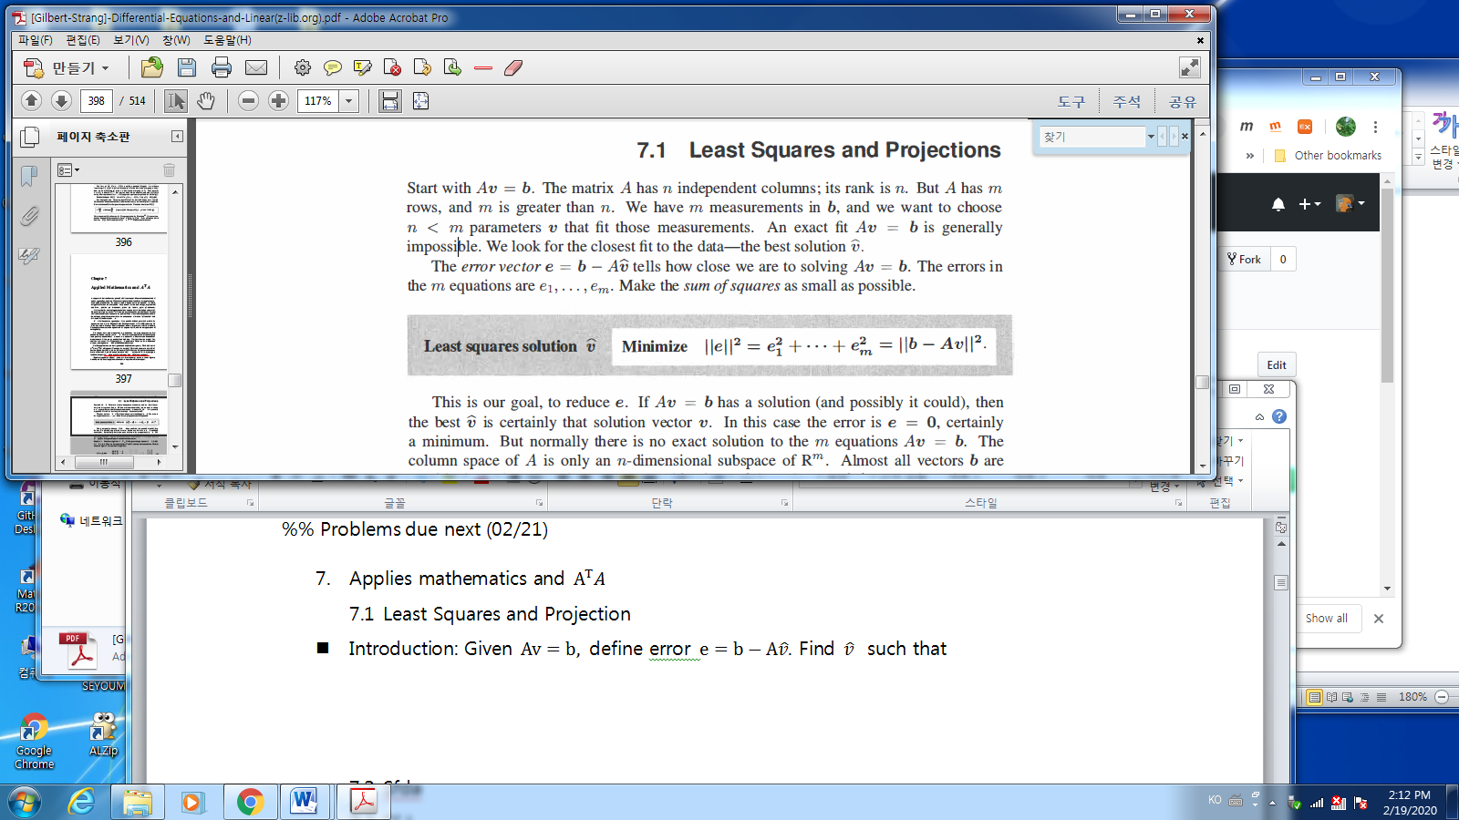

* Example: Find the straight line $b=C+Dt,$ such that the error is minimized

$$t=\left\{0,1,3,4\right\}, b=\{1,9,9,21\}$$

$$\left[\begin{matrix}1 & 0 \\ 1 & 1 \\ \begin{matrix}1 \\ 1\end{matrix} & \begin{matrix}3 \\ 4\end{matrix}\end{matrix}\right]\left[\begin{matrix}C \\ D\end{matrix}\right]=\left[\begin{matrix}1 \\ 9 \\ \begin{matrix}9 \\ 21\end{matrix}\end{matrix}\right]$$

*Solution: He already got the solution as $y=2+4t$

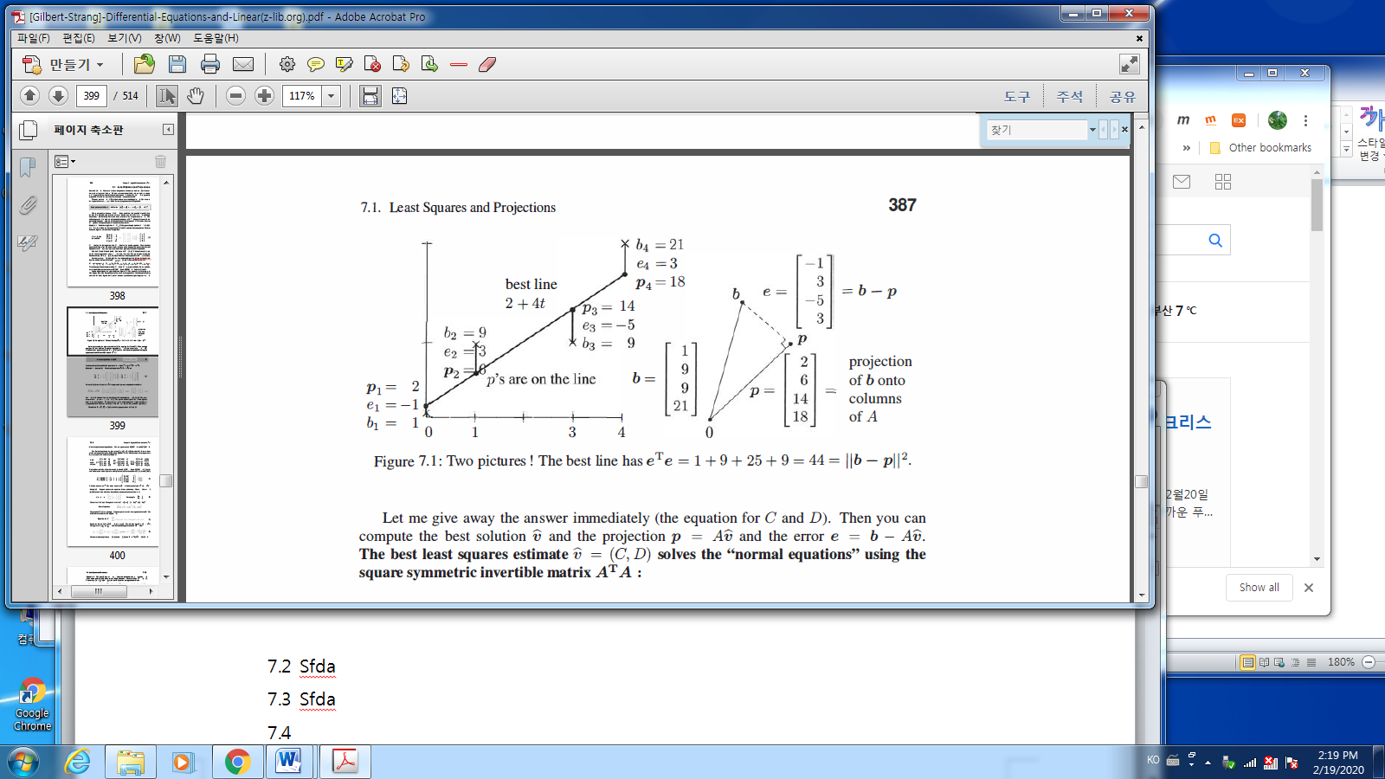

* In general the least Square Estimator:

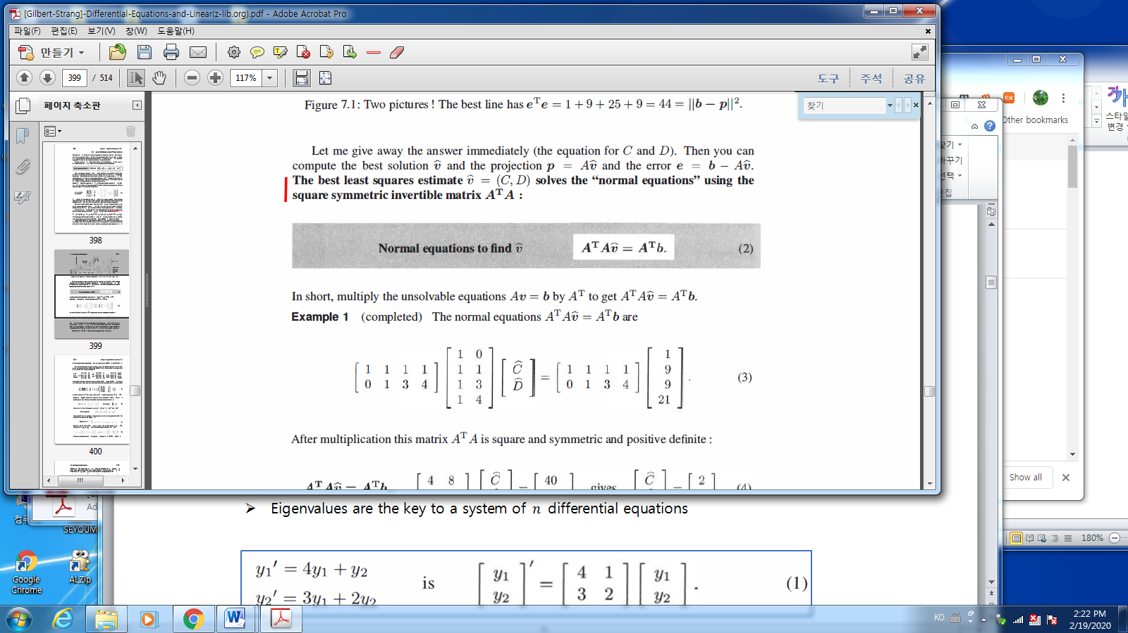

* Fact:

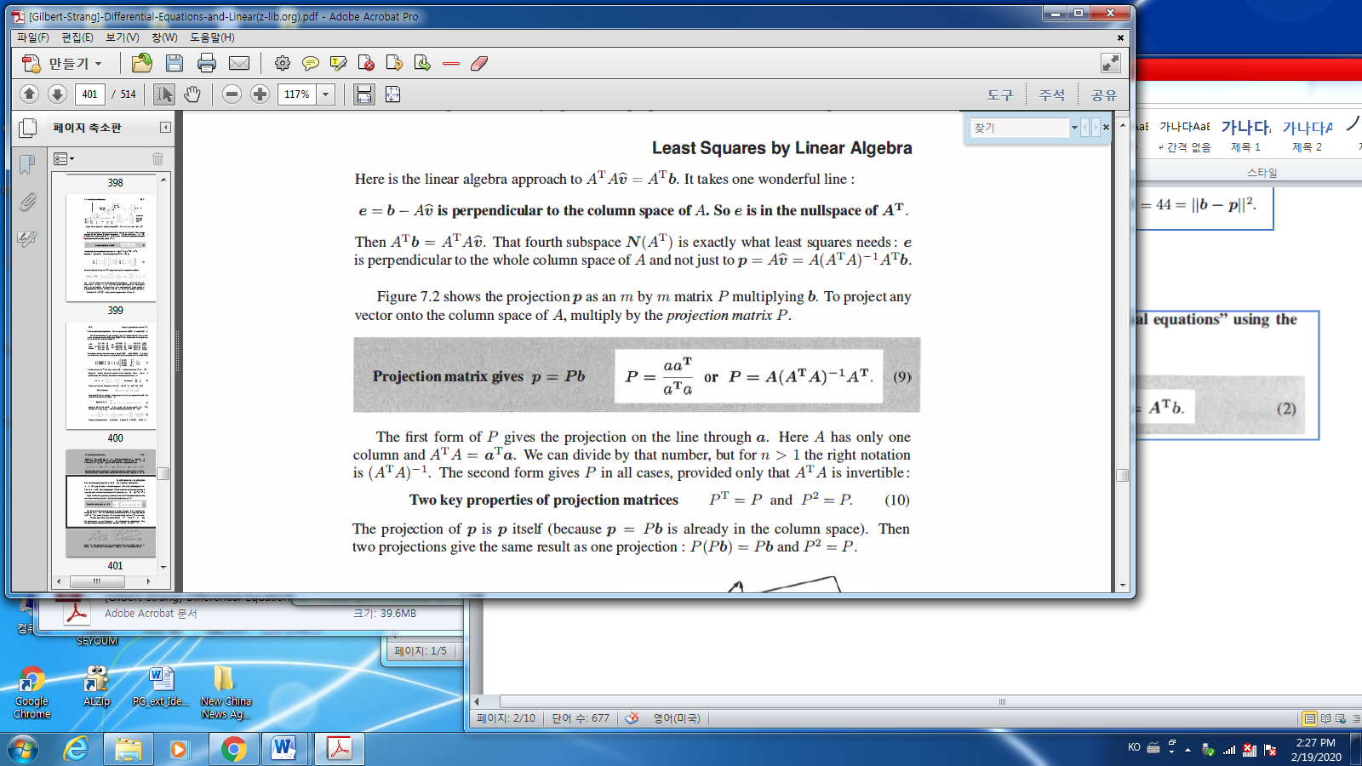

* Projection: vector $b$ projects on vector $a$

To project any vector onto the column space $A$, multiply by the projection matrix $P$

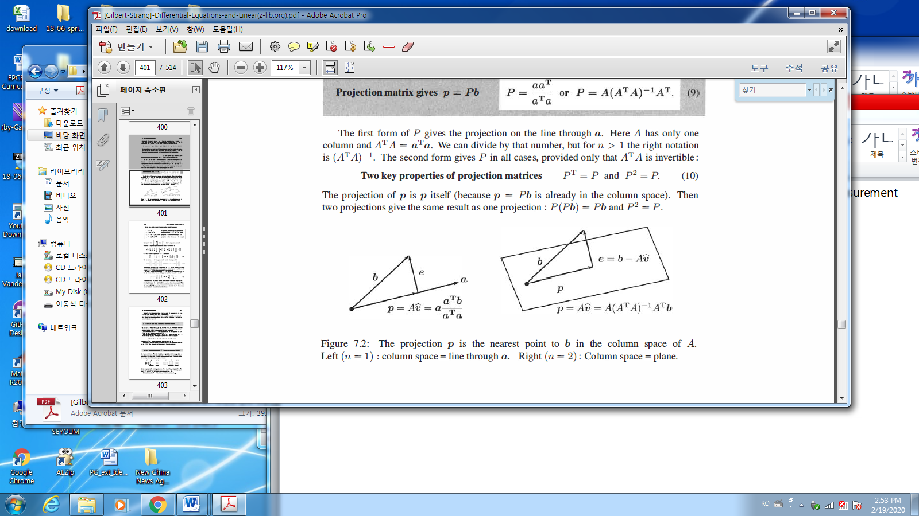

The projection vector $p,$ the vector $b$ projects on the vector

* Kim

Solution: from the picture, $a^{*}=a_{1}$ which is on the vector $a$.

From the definition of dot product

$$a∙b=\left\|a\right\|\left\|b\right\|\cos{θ}$$

implies

$$\cos{θ=\frac{a∙b}{\left\|a\right\|\left\|b\right\|}}$$

Hence the $a^{*}$ can be derived as

$$P_{a}\left(b\right)=a^{*}= \left\|b\right\|\cos{θ\frac{a}{\left\|a\right\|}}=\left\|b\right\|\frac{b∙a}{\left\|a\right\|\left\|b\right\|}{\frac{a}{\left\|a\right\|}}= \frac{b∙a}{{\left\|a\right\|}^{2}} a \\ =\frac{b^{T}a}{{\left\|a\right\|}^{2}}a=\frac{{aa}^{T}}{a^{T}a}b$$

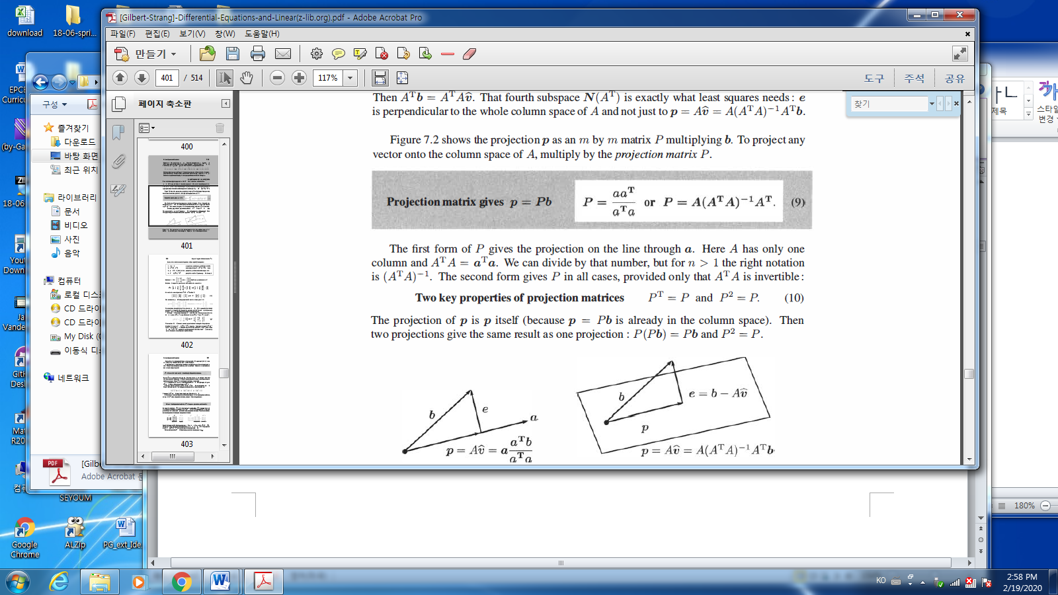

* Caution:
$$P=A{\left(A^{T}A\right)}^{-1}A^{T}=>A{\left(A^{-1}{(A}^{T}\right)}^{-1}A^{T})=AA^{-1}{\left(A^{T}\right)}^{-1}A^{T} =I? NO..$$

* Example

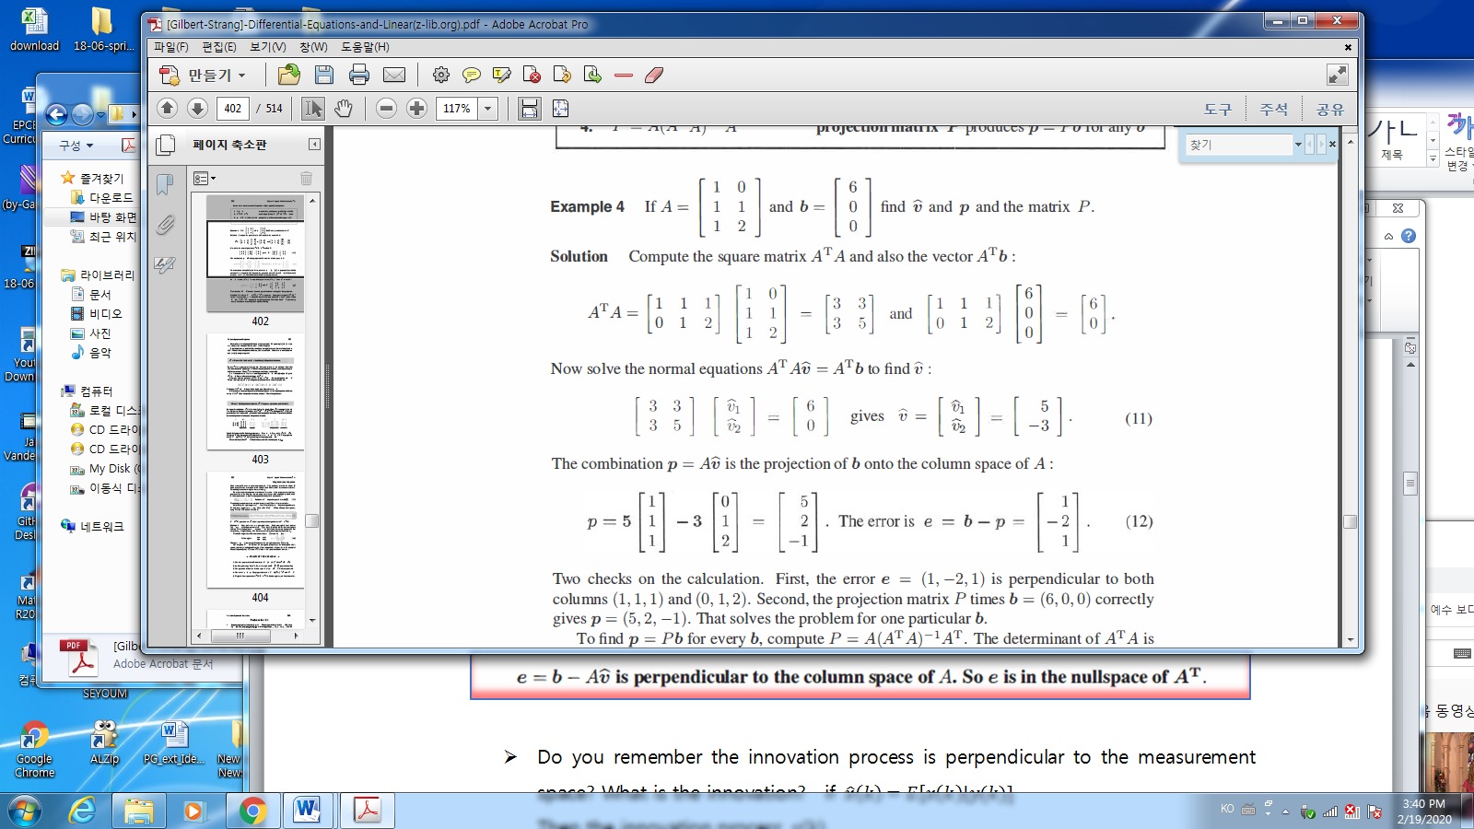

* Fact:

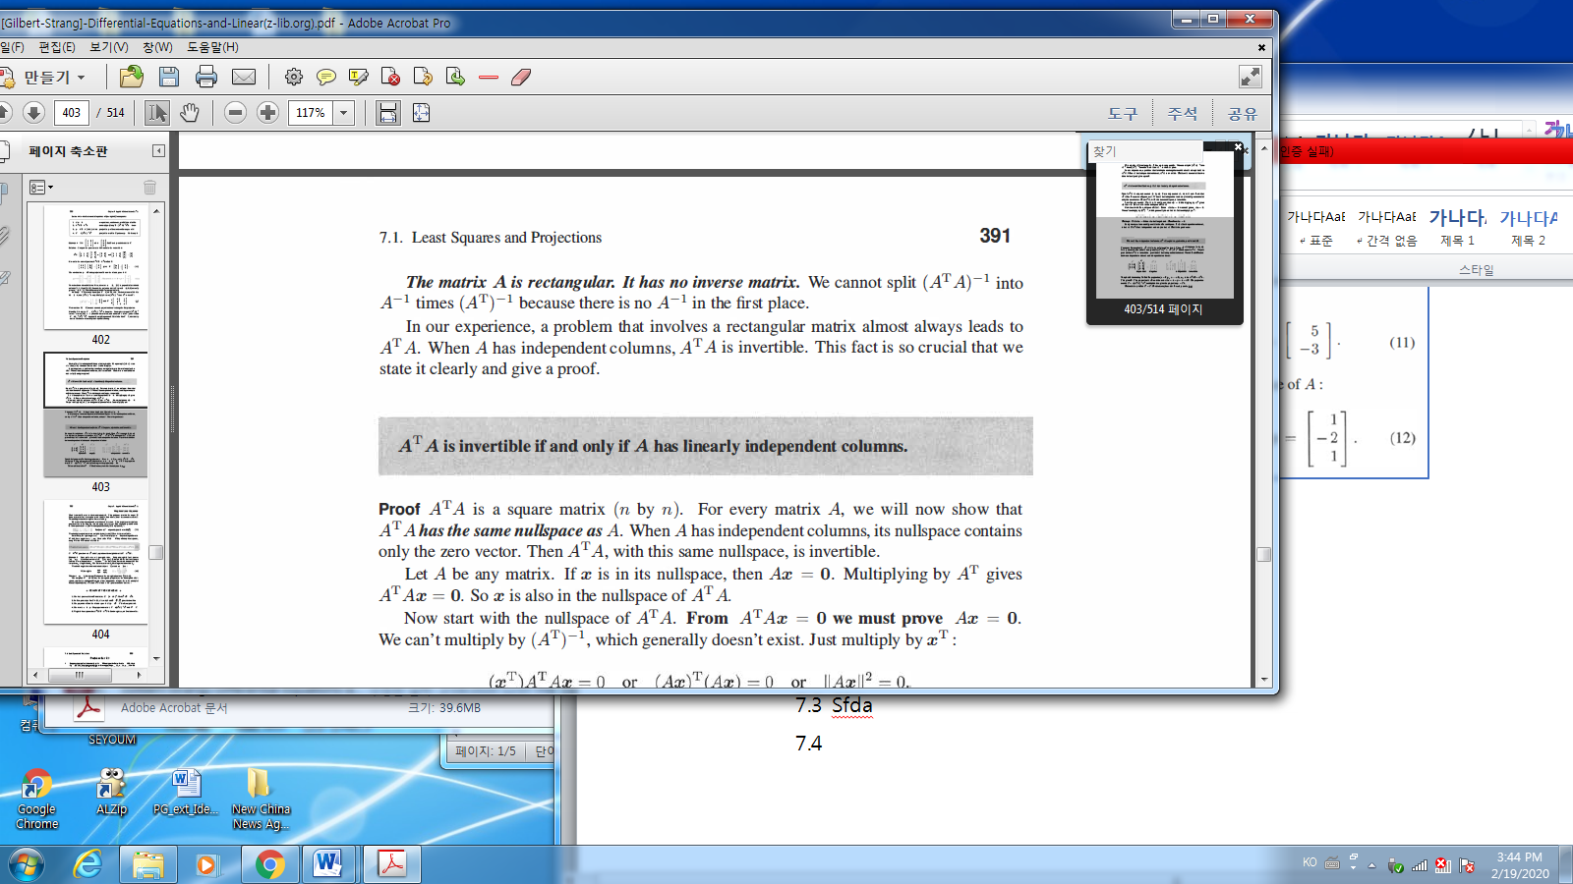

-

🡪 You may remember $A$ is invertible iff $A$ has linearly independent columns.

* 1. Positive Definite Matrices and SVD
* Definition of a positive definite matrix

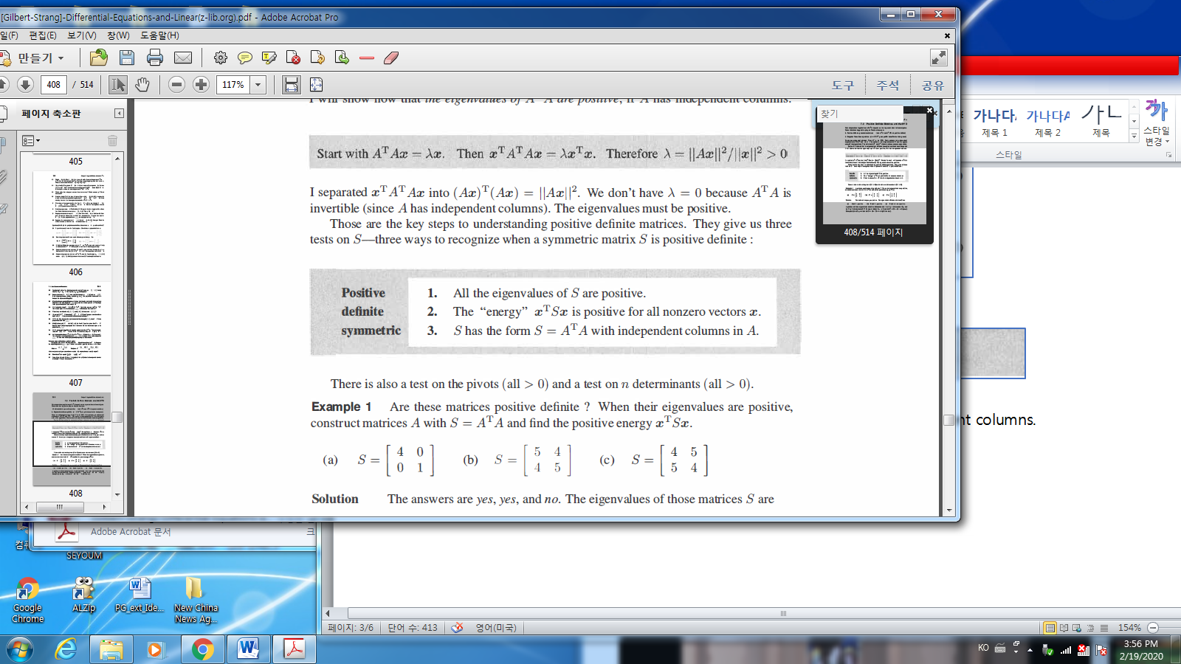

* Remember

1) but .

2) Let , Then $M^{T}=M,$ $λ\left(M\right)=λ\left(M^{T}\right)$

Let $N={AA}^{T}$, Then $N^{T}=M,$ $λ\left(N\right)=λ\left(N^{T}\right)$.

$λ_{i}\left(M\right)=λ_{i}\left(N\right), if λ_{i}≠0$

* Example

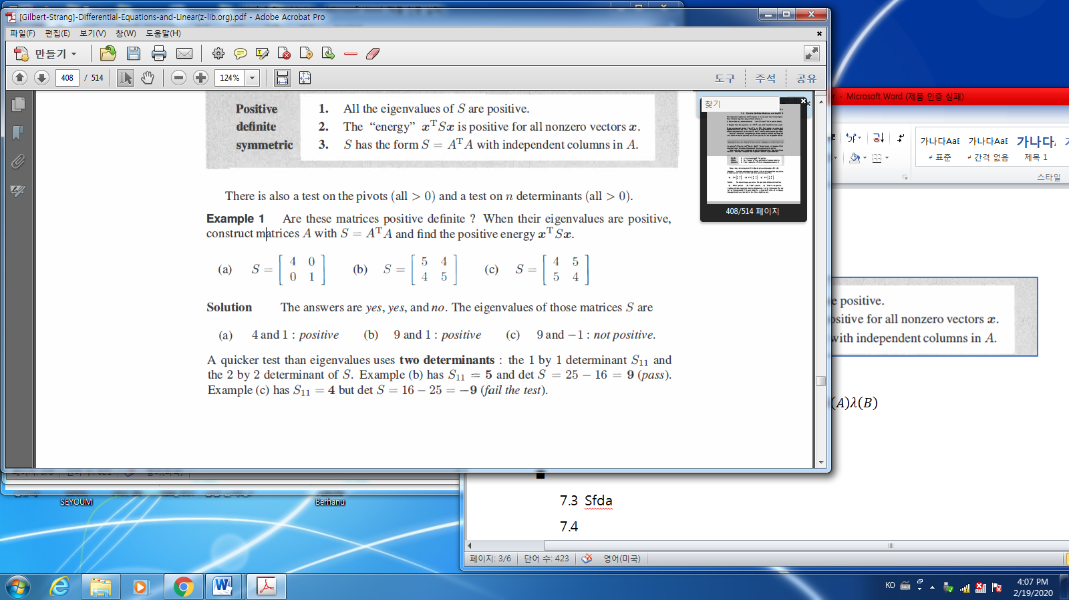

* Definition: Positive Semidefinite Matrices

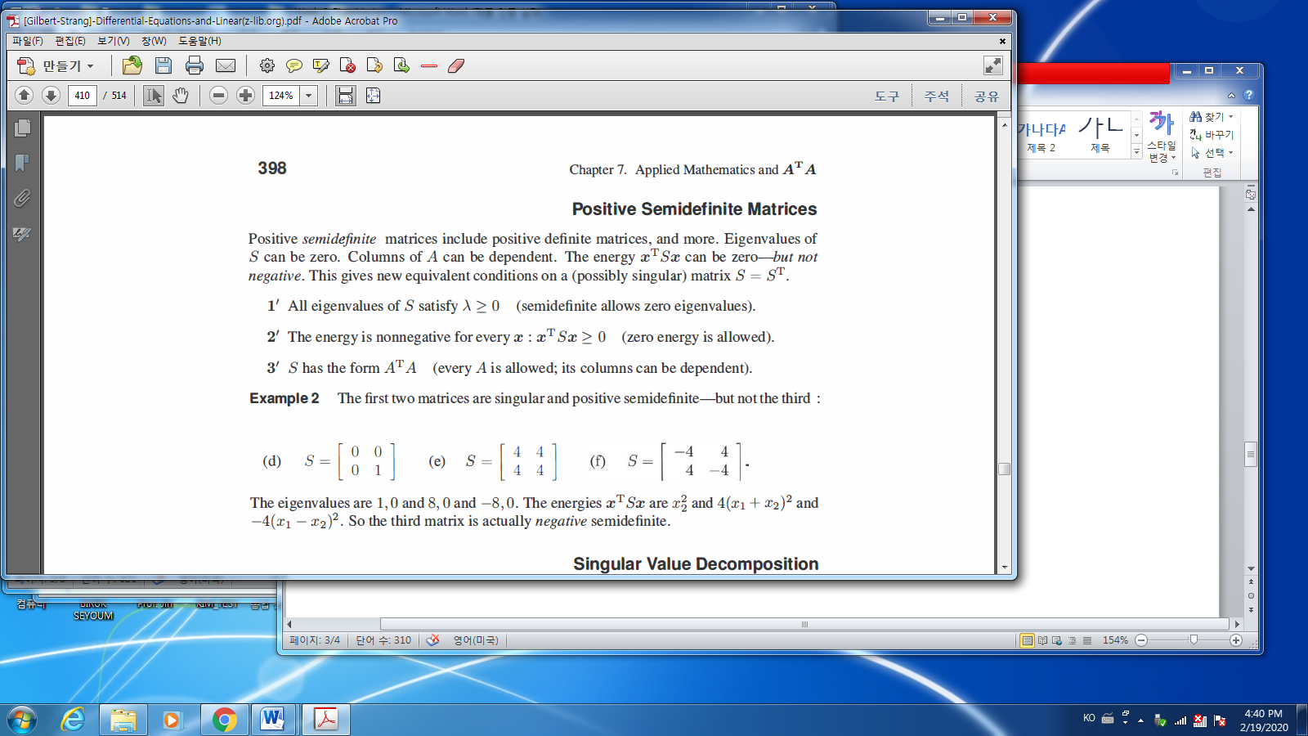

%%%%%%%%%%% Let us think one more e-values…

As you know, if $A$ is a **square matrix**, then it may be decomposed.

Let $\left(λ_{i},x_{i}\right), i=1,…,n$. Since $∃ n$ e-vectors, which may be a Basis,

$∀ x∈R^{n} ,$

$$x=c_{1}x_{1}+c_{2}x_{2}+,…,+c_{n}x_{n}$$

Hence

$$Ax=A\left(c_{1}x_{1}+c_{2}x_{2}+,…,+c_{n}x_{n}\right)=c_{1}λ_{1}x_{1}+,…,+c_{n}λ_{n}x_{n}$$

Now find a solution to a linear differential equation

$$\frac{dx}{dt}=Ax$$

Therefore

$$\frac{dx}{dt}=\frac{d\left(c_{1}x_{1}+c_{2}x_{2}+,…,+c_{n}x_{n}\right)}{dt}=c_{1}\frac{dx_{1}}{dt}+,…+c_{n}\frac{dx_{n}}{dt} (a)$$

And

$$Ax=A\left(c_{1}x_{1}+c_{2}x_{2}+,…,+c_{n}x_{n}\right) \\ =c_{1}λ_{1}x_{1}+,…,+c_{n}λ_{n}x_{n} (b)$$

Together (a) and (b), $\frac{dx}{dt}=Ax$ is decomposed into

$$\frac{dx}{dt}=c_{1}\frac{dx_{1}}{dt}+,…,+c_{n}\frac{dx_{n}}{dt}=c_{1}λ_{1}x_{1}+,…,+c_{n}λ_{n}x_{n}$$

$$\frac{{dx}_{1}}{dt}=λ_{1}x_{1},…..,\frac{dx_{n}}{dt}=λ_{n}x_{n}$$

%%%%%%% At least square matrices, it is possible to be decomposed. How about not

square matrix? We may have many situations

🡪 since $\left[10\right] ∈C\left(A\right),$ it is solvable

1. $x+3y+z=10, 2x+y+4z=5$,

$\left[\begin{matrix}1 & 3 & 1 \\ 2 & 1 & 4\end{matrix}\right]\left[\begin{matrix}x \\ y \\ z\end{matrix}\right]=\left[\begin{matrix}10 \\ 5\end{matrix}\right]-→$ since $\left[\begin{matrix}10 \\ 5\end{matrix}\right]∈C\left(A\right)$, it is solvable

1. 🡪 not solvable since

$$\left[\begin{matrix}1 & 3 & 1 \\ 2 & 1 & 4 \\ \begin{matrix}1 \\ 1\end{matrix} & \begin{matrix}1 \\ 2\end{matrix} & \begin{matrix}1 \\ 2\end{matrix}\end{matrix}\right]\left[\begin{matrix}x \\ y \\ z\end{matrix}\right]=\left[\begin{matrix}10 \\ 5 \\ \begin{matrix}1 \\ 2\end{matrix}\end{matrix}\right]$$

So, 3) is not solvable…What can we do best? One of the methods.

**For any matrix $A$** , square or rectangular, $"n"$ e-vectors, $A$ can be decomposed as

Singular value decomposition.

* Definition: Singular Value Decomposition

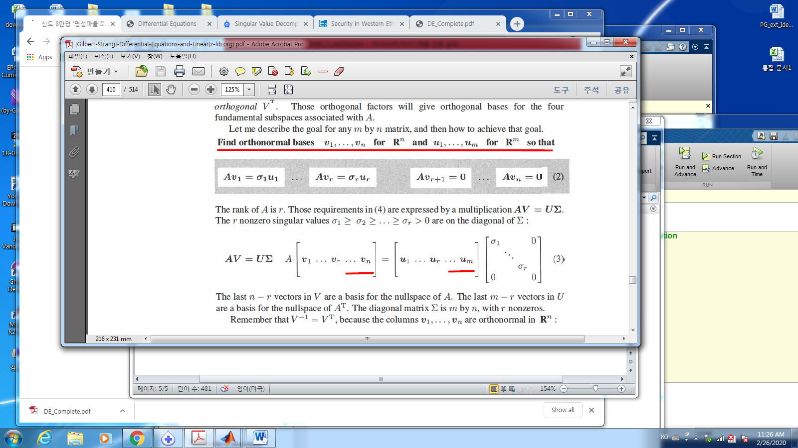

* Let $V=\left[v_{1},…,v_{n}\right], U=\left[u_{1},…,u_{m}\right], Σ=diag \left[ σ_{r}…0\right]$,

where $σ_{1}≥σ_{2}…≥σ_{r}>0$

Then (2) may be

$$AV=UΣ-→ A=UΣV^{T}$$

* If

A

U

$$Σ$$

$$V^{T}$$

* Example
$$A= \left[\begin{matrix}2 & 2 & 0 \\ -1 & 1 & 0\end{matrix}\right]=\left[\begin{matrix}1 & 0 \\ 0 & 1\end{matrix}\right]\left[\begin{matrix}\sqrt{8} & 0 & 0 \\ 0 & \sqrt{2} & 0\end{matrix}\right]{\left[\begin{matrix}\frac{\sqrt{2}}{2} & \frac{\sqrt{2}}{2} & 0 \\ \frac{\sqrt{2}}{2} & -\frac{\sqrt{2}}{2} & 0 \\ 0 & 0 & 1\end{matrix}\right]}^{T}$$

* Orthonomal vector $v_{i}$ is
* Orthogonality :
$$v_{i}^{T}v_{j}= \left\{\begin{aligned}1 if i=j \\ 0 if i≠j\end{aligned}\right.$$

* Normalized:
$${\left\|v_{i}\right\|}^{2}=1 ∀i$$

* The sigma value $σ , Av=σu$ is different from the eigenvalues as

$Ax=λx$

* Even if $A_{n×n}$ is a square matrix, $"n"$ e-vectors may not be orthogonal.
* If eigenvalues are different from each other, then the eigenvector are

Independent to each other, but may not be orthogonal

* **If $A$ is a symmetric matrix, then e-values are real and orthogonal(Ch.4)**

Hence if $A=A^{T}$, then $\left|λ\left(A\right)\right|=σ(A)$.

* **Our problem is for any matrix.**
* $R^{n}$, there are many orthonormal bases. How about in $R^{m}$.How can we find?

$u_{i}, σ_{k}, v_{j}$?

* Find $v_{i}, σ_{k}, u_{j}$

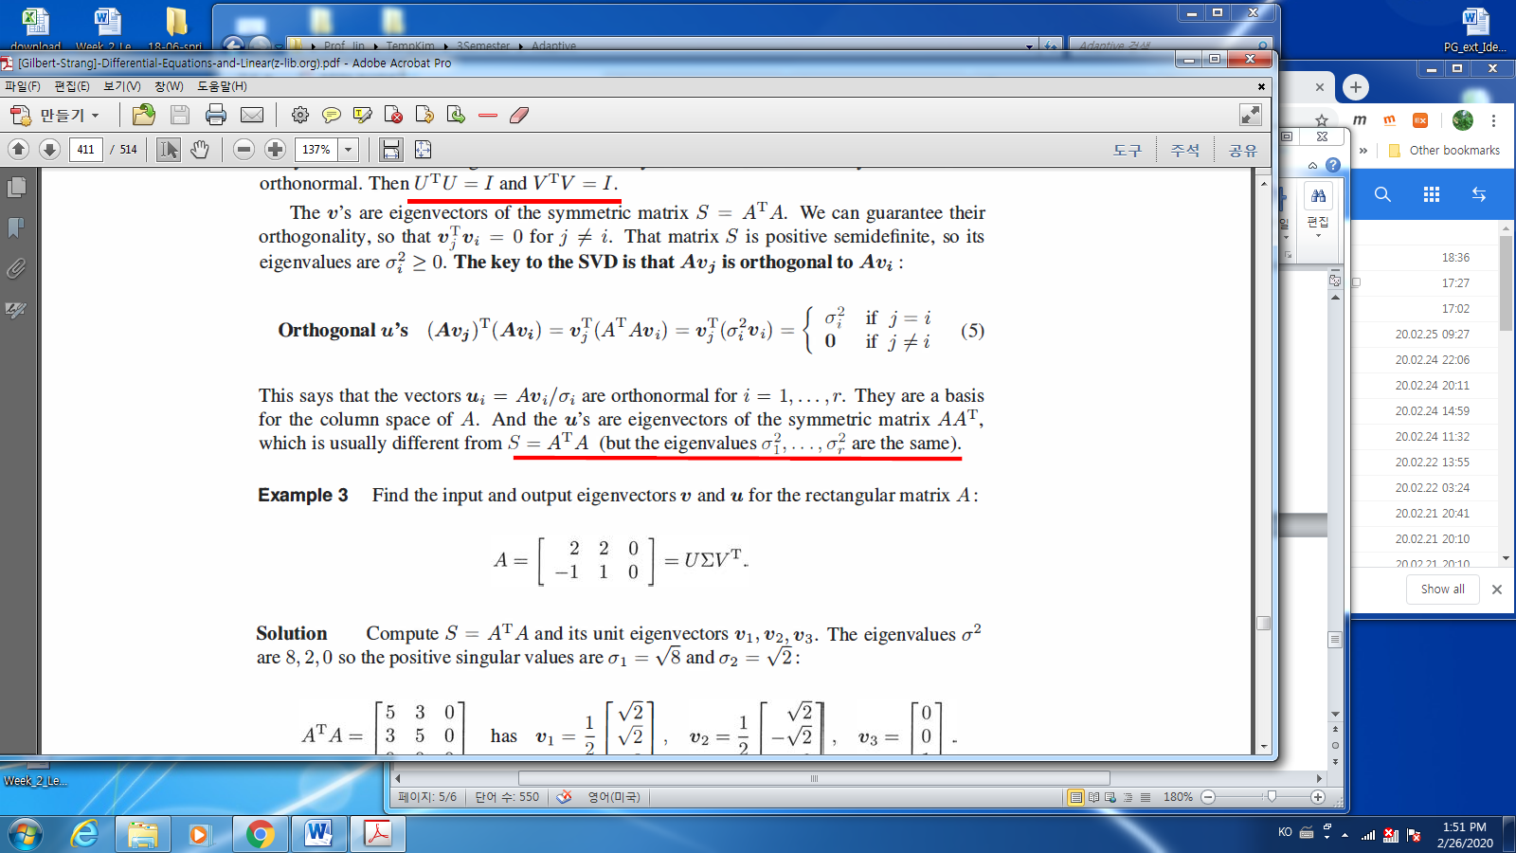

Since ${Av}_{i}=σ_{i}u_{i}$, $u_{j}, u_{i}$ are orthogonal, $u_{j}^{T}u_{i}=0 , if j≠i$

$$\left(σ_{j}σ_{i}u_{j}^{T}u_{i}\right)={\left(Av_{j}\right)}^{T}\left(Av_{i}\right)=v_{j}^{T}\left(A^{T}A\right)v_{i}$$

By the assumption of $u_{j}, u_{i}$ are orthonormal,

$$v_{j}^{T}\left(A^{T}A\right)v_{i}=\left\{\begin{aligned}σ_{i}^{2} if j=i \\ 0 if j≠ i\end{aligned}\right. (1)$$

By the assumption of $v_{j}, v_{i}$ are orthonormal, and normalized

$$v_{i}^{T}v_{j}= \left\{\begin{aligned}1 if i=j \\ 0 if i≠j \end{aligned}\right.$$

Let the eigenvalues of $\left(A^{T}A\right)$, be $λ_{i}, x$, and assume the corresponding

eigenvector are $v_{i}$

$$v_{j}^{T}\left(A^{T}A\right)v_{i}=λ$$

Then from (1)

$$v_{j}^{T}\left(A^{T}A\right)v_{j}=v_{j}^{T}\left(λ\left(A^{T}A\right)\right)v_{j}= λ\left(A^{T}A\right)v_{j}^{T}v_{j}= λ\left(A^{T}A\right)$$

Hence

Hence $σ^{2}=λ\left(A^{T}A\right) , v_{i}= \frac{eigen vector(A^{T}A)}{\left\|eigenvector(A^{T}A)\right\|} , for being normalized$

About $u_{i}$, from the ${Av}_{i}=σ_{i}u_{i}$, if $σ_{i}≠0$, then $u_{i}=\frac{Av_{i}}{σ_{i}}$, and if $σ_{i}=0,$ then you may

find the others using “Gramm-Schmidt” until the number of $u$ is “n”.

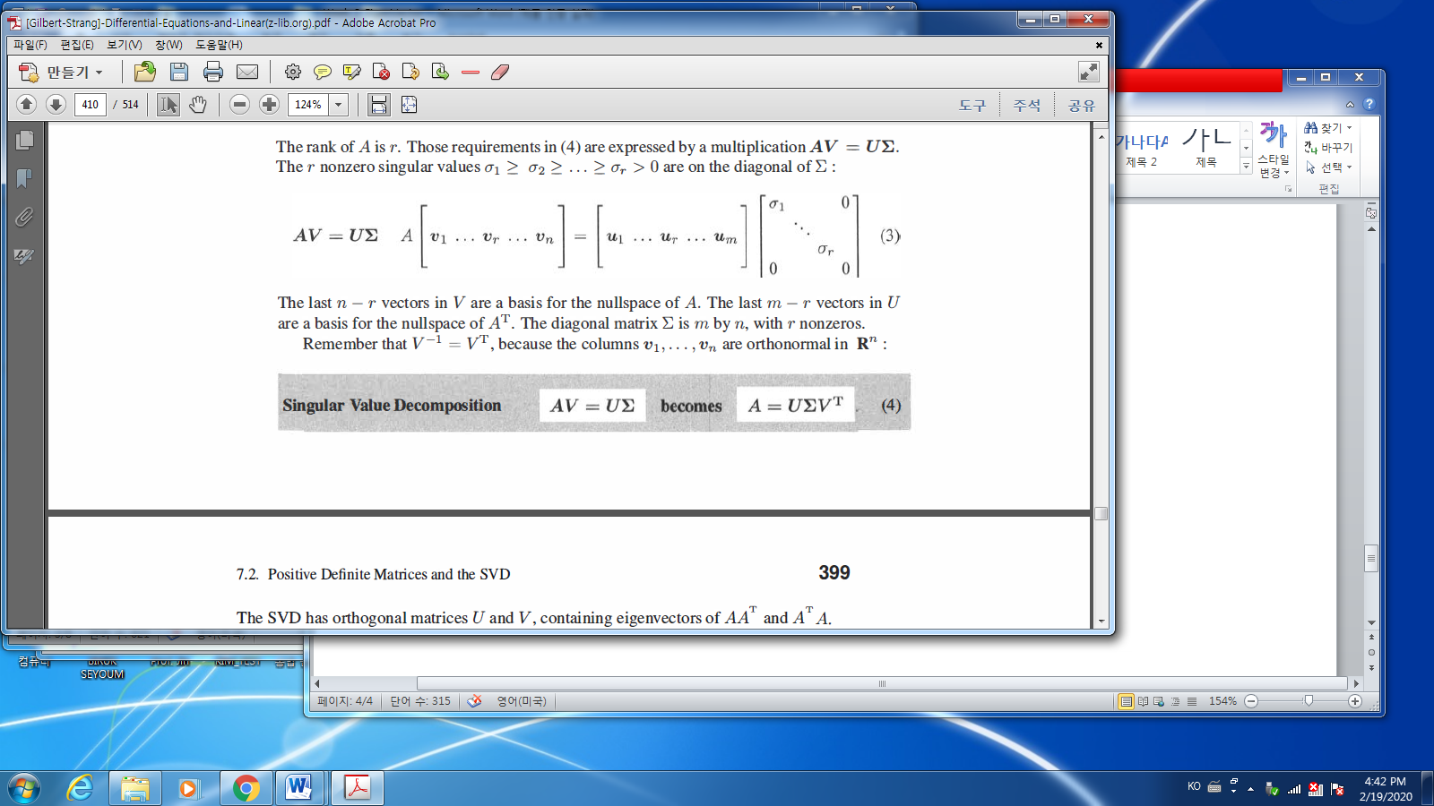

* Fact:

${AA}^{T}U = UΣ^{2}$, $A^{T}A V=VΣ^{2}$, $a_{ij}= \sum_{k=1}^{n}{u_{ik}σ_{k}v_{jk}}, A=\left(a_{ij}\right)$

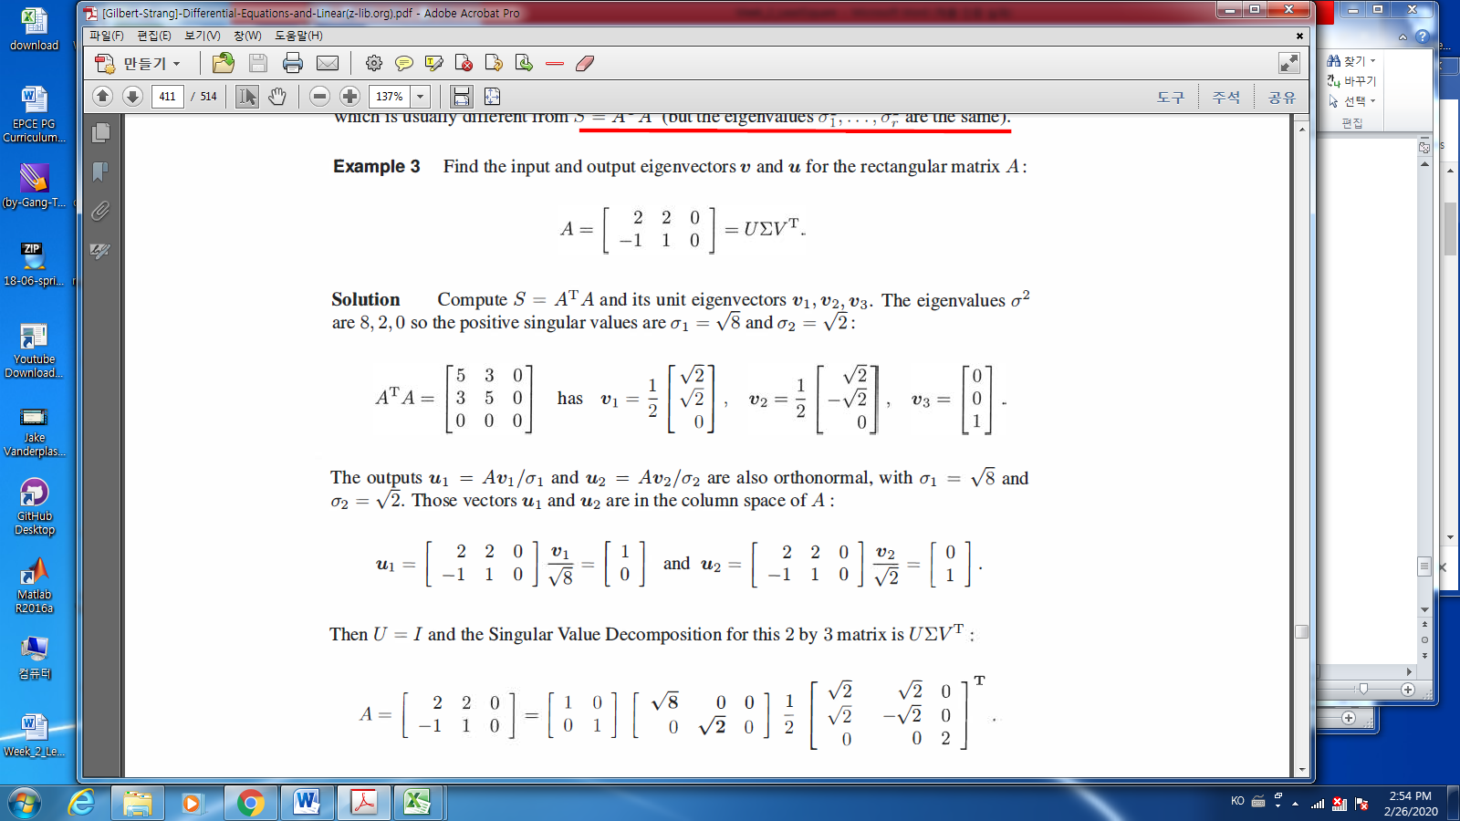

* Kim’s Gram – Schmidt orthogonalization

<https://en.wikipedia.org/wiki/Gram%E2%80%93Schmidt_process>

Given a linearly independent set of vectors in $R^{n}$

$$\{v_{1}, v_{2},…,v_{k}\}$$

Find an orthogonal vectors such that

$$\{u_{1}, u_{2},…,u_{k}\}$$

such that they are orthogonal, i.e.,

$$u_{i}^{T}u_{j}= \left\{\begin{aligned}1 if i=j \\ 0 otherwise\end{aligned}\right.$$

1. Find an orthogonal vectors

* Pick up any vector $v_{1}$, define $u_{1}=v_{1}$
* Calculate $u_{2}$
$$u_{2}=v_{2}-Proj_{u_{1}}(v_{2})$$

* Calculate $u_{3}$
$$3=v_{3}-Proj_{u_{1}}\left(v_{3}\right)-Proj_{u_{2}}(v_{3})$$

* Repeat until $u_{k}$

1. Normalize $\{u_{1}, u_{2},…,u_{k}\}$ such as
 $$u_{i} = \frac{u_{i}}{\left\|u_{i}\right\|}$$

  1. Boundary conditions replace initial conditions -skip
   2. Laplace’s Equation and $A^{T}A$-skip
   3. Networks and the Graph Laplacian - skip

%% The first exam. Candidate problems.

Ch.7.1 10/11 / 21 /22

Ch.7.2 3 / 4 / 12 / 27

Who is interested in Ch.7.2 problem 32~~